**MINI TABLE FANS:**

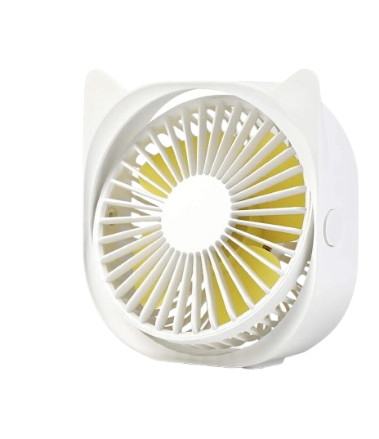

**Price: 4,999.00**

The Mini Table Fan is a compact and portable ventilation solution, designed to provide personal cooling relief in small spaces. With its tiny footprint and lightweight design, this fan is perfect for desks, tables, and other compact areas, delivering a gentle breeze that keeps you cool and comfortable. Its quiet operation, adjustable speed settings, and energy-efficient design make it an ideal choice for offices, dorm rooms, and other small spaces where a discreet and effective cooling solution is needed.

**Key features of mini table include:**

* **Compact Size** – Small and space-saving, perfect for desks or tight spaces.
* **Portability** – Lightweight and easy to move or transport.
* **Adjustable Speed** – Multiple speed settings for customized airflow.
* **Quiet Operation** – Designed to run quietly, ideal for personal use in quiet spaces.
* **Energy Efficient** – Low power consumption for cost-effective cooling.
* **Adjustable Tilt** – Allows airflow direction to be adjusted for comfort.
* **USB or Battery Powered** – Often powered by USB or rechargeable batteries for convenience.